**SECURITY SERVICE MANAGEMENT SYSTEM FOR RALL**

**Sri Lanka Institute of Information Technology**



**IT2080 – Information Technology Project**

**Activity 1**

**Group ID: ITP24R_B1_W22**

**Team Members**

1. **Fernando K. K. C : IT22325228**
2. **Saisha R. M. M : IT22907998**
3. **Dissanayaka D. M. S. M : IT20145552**
4. **Randiw E. Y : IT22257086**
5. **Jayodhya J. D. H : IT22293480**
6. **Medawatte W. W. M. T. N. B : IT22127082**
7. **Kusumsiri P. A. S. S : IT22132628**
8. **Ranasinghe R. A. R. V. C : IT22197146**

**Date:** 31.07.2024

**Contents**

PART 1 3

01. Stakeholders 3

02.Onion Diagram 3

PART 2 4

01. User Stories 4

**A Manager’s Story** 4

**A Training Manager’s Story** 4

**A Client Manager’s Story** 5

**An Operation Manager’s Story** 5

**A Payment Manager’s Story** 6

**A Booking Manager’s Story** 6

**An Inventory Manager’s Story** 7

**A Supplier Manager’s Story** 7

**A Client’s Story** 8

**A Supplier’s Story** 8

**A Security Officer’s Story** 9

**A Training Instructor’s Story** 9

**A Job Candidator’s Story** 10

PART 3 11

01. Functional Requirements (FR) 11

02. Non-Functional Requirements (NFR) 13

03. Technical Requirements (TR) 15

PART 4 16

01. Use Case Diagrams 16

PART 5 25

01. Use Case Scenario 25

# PART 1

## 01. Stakeholders

* Manager
* Training Manager
* Client Manager
* Operation Manager
* Payment Manager
* Booking Manager
* Inventory Manager
* Supplier Manager
* Client
* Supplier
* Security Officer
* Training Instructor
* Job Candidator

## 02.Onion Diagram

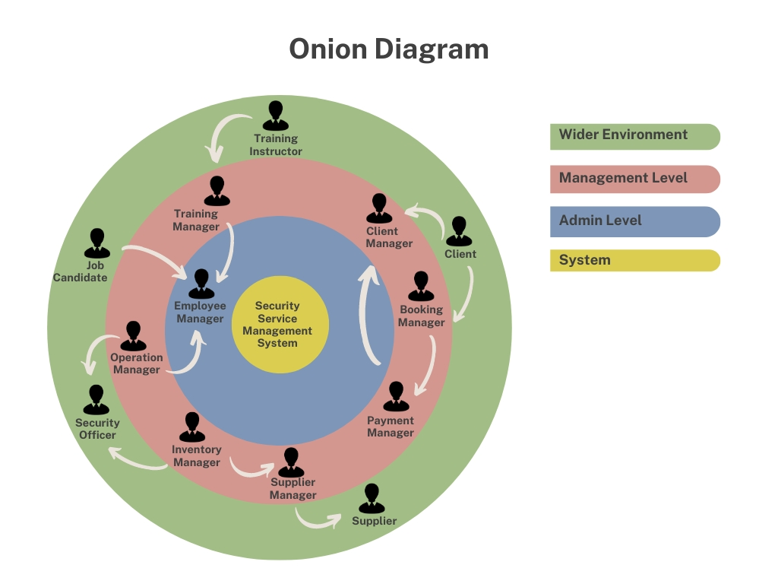

# PART 2

## 01. User Stories

**A Manager’s Story**

* **As a Manager,**

I want to manage employee details and requirements,

So that I can ensure all employee records are accurate and up-to-date.

* **As a Manager,**

I want to handle interviews for potential security officers,

So that I can recruit the best candidates for the job.

* **As a Manager,**

I want to create and provide login details for employees and managers,

So that they can access the system securely.

**A Training Manager’s Story**

* **As a Training Manager,**

I want to manage training sessions,

So that I can ensure all security officers receive necessary training.

* **As a Training Manager,**

I want to manage training instructors,

So that I can coordinate training activities efficiently.

* **As a Training Manager,**

I want to credit security officers for completing training courses,

So that their professional development is recognized.

**A Client Manager’s Story**

* **As a Client Manager,**

I want to manage client details,

So that I can maintain accurate records and ensure client satisfaction.

* **As a Client Manager,**

I want to create and provide client login details,

So that clients can access their accounts securely.

* **As a Client Manager,**

I want to gather and document client requirements,

So that I can provide services that meet their needs.

**An Operation Manager’s Story**

* **As an Operation Manager,**

I want to check the current status of security officers,

So that I can ensure they are performing their duties.

* **As an Operation Manager,**

I want to manage security officers when appointing them to locations,

So that all security needs are covered effectively.

* **As an Operation Manager,**

I want to handle security officer problems,

So that any issues are resolved quickly and efficiently.

**A Payment Manager’s Story**

* **As a Payment Manager,**

I want to generate invoices for clients,

So that all services provided are billed accurately.

* **As a Payment Manager,**

I want to check the payment status of clients,

So that I can follow up on any overdue payments.

* **As a Payment Manager,** I want to confirm payments,

So that I can ensure all transactions are recorded properly.

**A Booking Manager’s Story**

* **As a Booking Manager,**

I want to check for new bookings,

So that I can allocate resources as needed.

* **As a Booking Manager,**

I want to manage all bookings,

So that all client requests are handled efficiently.

* **As a Booking Manager,**

I want to resolve online booking issues,

So that clients have a smooth booking experience.

**An Inventory Manager’s Story**

* **As an Inventory Manager,**

I want to provide uniforms and equipment to security officers,

So that they are properly equipped for their duties.

* **As an Inventory Manager,**

I want to manage stock levels,

So that I can ensure we have adequate supplies at all times.

* **As an Inventory Manager,**

I want to inform the Supplier Manager about stock details for restocking,

So that inventory levels are maintained.

**A Supplier Manager’s Story**

* **As a Supplier Manager,**

I want to reorder stocks,

So that we never run out of essential items.

* **As a Supplier Manager,**

I want to manage supplier relationships,

So that we can ensure timely deliveries and quality supplies.

* **As a Supplier Manager,**

I want to track supplier performance,

So that I can address any issues that arise.

**A Client’s Story**

* **As a Client,**

I want to request security officers for events,

So that I can ensure safety and security.

* **As a Client,**

I want to request lady security officers for functions,

So that I can have gender-specific security as needed.

* **As a Client,**

I want to request VVIP officers with weapons,

So that high-profile events are adequately protected.

**A Supplier’s Story**

* **As a Supplier,**

I want to provide uniforms for security officers,

So that they have proper attire for their duties.

* **As a Supplier,**

I want to supply weapons,

So that security officers are equipped for their roles.

* **As a Supplier,**

I want to provide other necessary equipment,

So that security officers can perform their duties effectively.

**A Security Officer’s Story**

* **As a Security Officer,**

I want to go to scheduled locations for duty,

So that I can fulfill my assignments.

* **As a Security Officer,**

I want to search for locations where I should go on duty,

So that I am aware of my assigned tasks.

* **As a Security Officer,**

I want to collect payments for services rendered,

So that financial transactions are completed.

**A Training Instructor’s Story**

* **As a Training Instructor,**

I want to train newly joined security officers,

So that they are prepared for their roles.

* **As a Training Instructor,**

I want to conduct personal development sessions for security officers,

So that they can enhance their skills.

* **As a Training Instructor,**

I want to manage training courses,

So that training programs are well-organized and effective.

**A Job Candidator’s Story**

* **As a Job Candidator,**

I want to seek security job opportunities,

So that I can find employment after retiring from the army.

* **As a Job Candidator,**

I want to apply for relevant positions,

So that I can be considered for security roles.

* **As a Job Candidator,**

I want to track the status of my job applications,

So that I am informed about my employment prospects.

# PART 3

## 01. Functional Requirements (FR)

**Employee Management**

* Allow the Manager to add, read, update, and delete employee details.
* Allow the Manager to store employee basic information and professional qualifications.
* Allow the Manager to handle interviews and manage security officer requirements.
* Allow the Manager to create and provide login details for employees and department managers (User Access Control).
* Allow the Manager to generate monthly reports, including net income, and profit reports.
* Handle Employee Leaves.

**Training Management**

* Allow the Training Manager to add, edit, and delete training schedules.
* Show training instructors their training schedules.
* Allow the Training Manager to manage training sessions and instructors.
* Allow the Training Manager to assign training courses and credit security officers for completed training.
* Allow the Training Manager to generate reports on training sessions and instructor performance.

**Client Management**

* Allow the Client Manager to create and manage client accounts, including providing login details.
* Allow the Client Manager to gather and document client requirements.
* Allow the Client Manager to update or delete client information, login details also.
* Show clients their service history and upcoming security services.
* Allow the Client Manager to generate reports on client interactions and satisfaction.

**Operation Management**

* Allow the Operation Manager to check the current status of security officers.
* Allow the Operation Manager to manage the deployment of security officers to different locations.
* Allow the Operation Manager to handle security officer problems and incidents.
* Allow security officers to report issues directly to the Operation Manager.
* Allow the Operation Manager to generate operational reports, including deployment schedules and incident logs.

**Payment Management**

* Allow the Payment Manager to generate invoices for clients.
* Allow the Payment Manager to check the payment status of clients and confirm payments.
* Allow the Payment Manager to generate financial reports on client payments and overall revenue.

**Booking Management**

* Allow clients to request security officers for events.
* Allow clients to request specific types of security officers (e.g., lady officers, VVIP officers).
* Allow the Booking Manager to check and manage new bookings.
* Allow the Booking Manager to resolve online booking issues.
* Allow the Booking Manager to handle security officers' payments by event.

**Stock/Inventory Management**

* Allow the Inventory Manager to provide uniforms and equipment to security officers.
* Allow the Inventory Manager to manage stock levels and update inventory records.
* Allow the Inventory Manager to inform the Supplier Manager about stock details for restocking.
* Allow the Inventory Manager to generate reports on stock usage and inventory levels.

**Supplier Management**

* Allow the Supplier Manager to add, read, update, and delete supplier details.
* Allow the Supplier Manager to reorder stocks and manage supplier relationships.
* Allow suppliers to accept or reject orders for uniforms, weapons, and other equipment.
* Allow the Supplier Manager to track supplier performance and generate reports on supplier activities and order statuses.

## 02. Non-Functional Requirements (NFR)

**Reliability, Availability, Scalability, User-friendly, Usability, and Security**

* The system should be reliable, ensuring consistent performance and accuracy in all operations.
* The system should be highly available, providing 24/7 access with minimal downtime.
* The system should be scalable, capable of handling an increasing number of users and growing data volumes.
* The system should be user-friendly, with an intuitive interface that is easy to navigate for all user types.
* The system should be usable, ensuring that all functions are easily accessible and operable by users with varying levels of technical proficiency.
* The system should be secure, protecting the confidentiality, integrity, and availability of all data.

**Concurrency Handling**

* The system should be able to handle many concurrent users without performance degradation.
* The system should use efficient load balancing and resource management techniques to ensure smooth operation under high user loads.

**Availability**

* The system should be available 24/7 with a target uptime of 99.9%.
* Scheduled maintenance should be minimal and communicated to users in advance.
* The system should have failover mechanisms in place to minimize the impact of any potential downtime.

**User-Friendly Interface**

* The system should provide a clean, intuitive interface that facilitates easy navigation and use.
* The system should offer helpful tooltips, guides, and documentation to assist users in completing their tasks.

**Usability**

* The system should be designed with usability in mind, ensuring that users can efficiently perform their tasks without unnecessary complexity.
* The system should offer responsive design, ensuring usability across various devices and screen sizes.

**Security**

* The system should implement robust authentication and authorization mechanisms to control access to different functionalities and data.
* The system should encrypt sensitive data both in transit and at rest to ensure data privacy and security.
* The system should regularly undergo security audits and vulnerability assessments to identify and mitigate potential risks.

**Performance**

* The system should have low latency, with response times of under 2 seconds for most user actions.
* The system should optimize database queries and backend processes to ensure quick data retrieval and updates.

**Scalability**

* The system should be designed to easily scale horizontally, allowing for the addition of more servers to handle increased load.
* The system should support load balancing to distribute user requests evenly across available resources.

**Maintainability**

* The system should be designed with modular architecture, allowing for easy updates and maintenance.
* The system should have comprehensive logging and monitoring to facilitate troubleshooting and performance tuning.

**Compatibility**

* The system should be compatible with major web browsers (e.g., Chrome, Firefox, Safari, Edge).
* The system should ensure cross-platform compatibility, supporting access from various operating systems (e.g., Windows, macOS, Linux, iOS, Android).

**Backup and Recovery**

* The system should implement regular automated backups to prevent data loss.
* The system should have a robust disaster recovery plan in place to restore operations quickly in the event of a failure.

## 03. Technical Requirements (TR)

**Development Stack**

* **MERN Stack:** The application will be developed using the MERN Stack, which includes:
  + **MongoDB:** For database management.
  + **Express.js:** For building the server-side logic.
  + **React.js:** For building the client-side user interface.
  + **Node.js:** For server-side runtime environment.

**Version Control**

* **GitHub:** A cloud-based version control system will be used to manage and collaborate on the codebase.

**Development Environment**

* **Visual Studio Code (VS Code):** The primary Integrated Development Environment (IDE) used for development.

**Utilities**

* **ChatGPT:** Developed by OpenAI, ChatGPT will be used to assist in the development of specific features such as a BMI calculator.
* The system should be built using a client-server architecture.

- The system should be compatible with different web browsers and devices.

- The system should be hosted on a secure and reliable web server.

# PART 4

## 01. Use Case Diagrams

**The whole system Use Case Diagram**

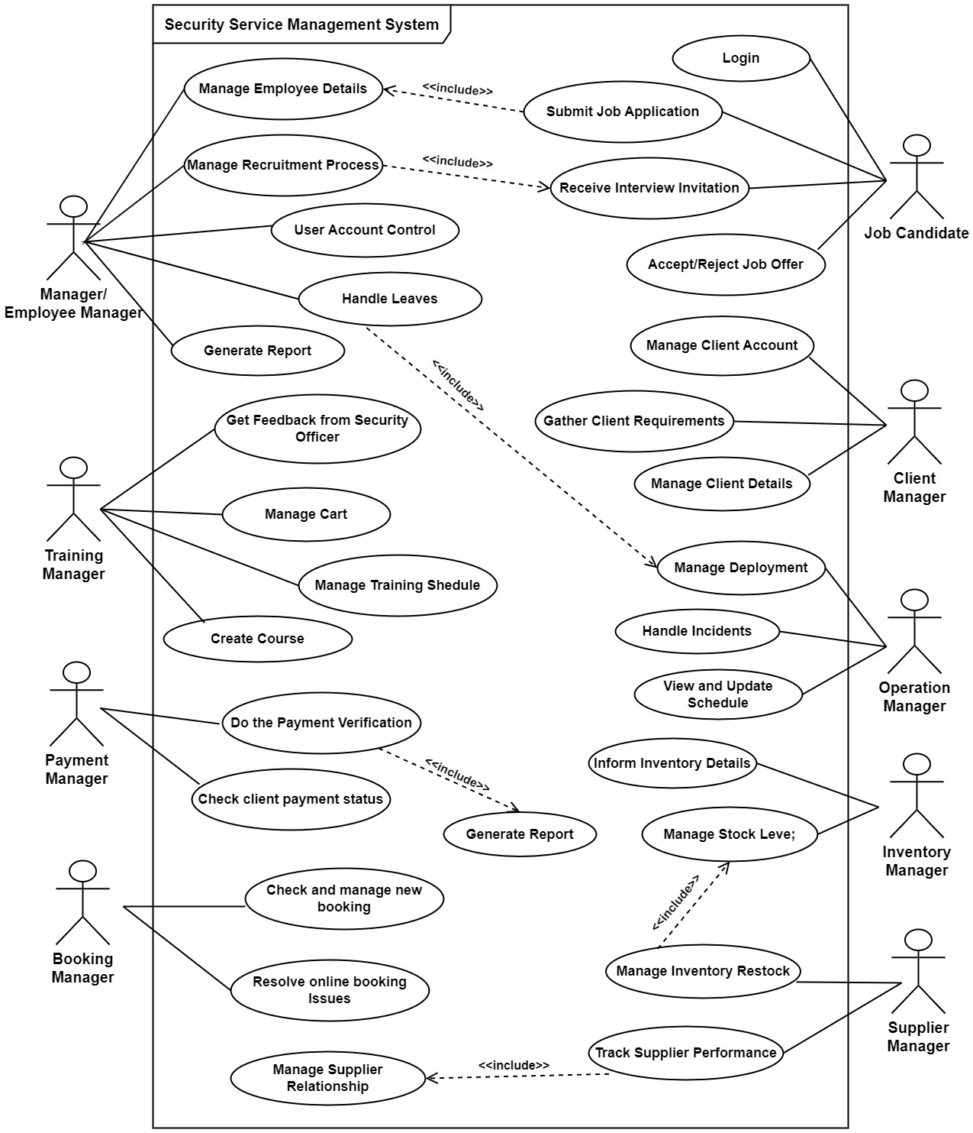

1. **Employee Management: IT22325228 – Fernando K. K. C**

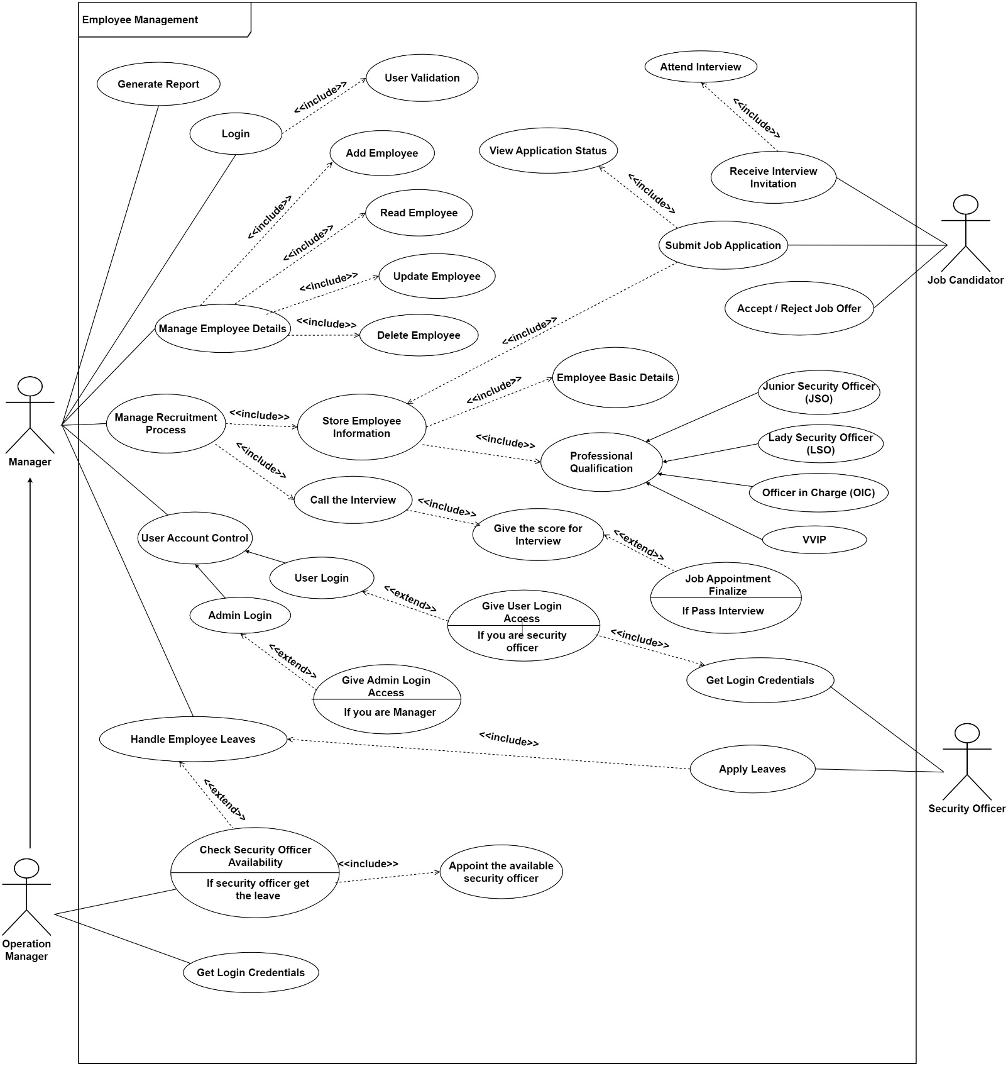

1. **Training Management: IT22907998 - Sadisha R. M. M**

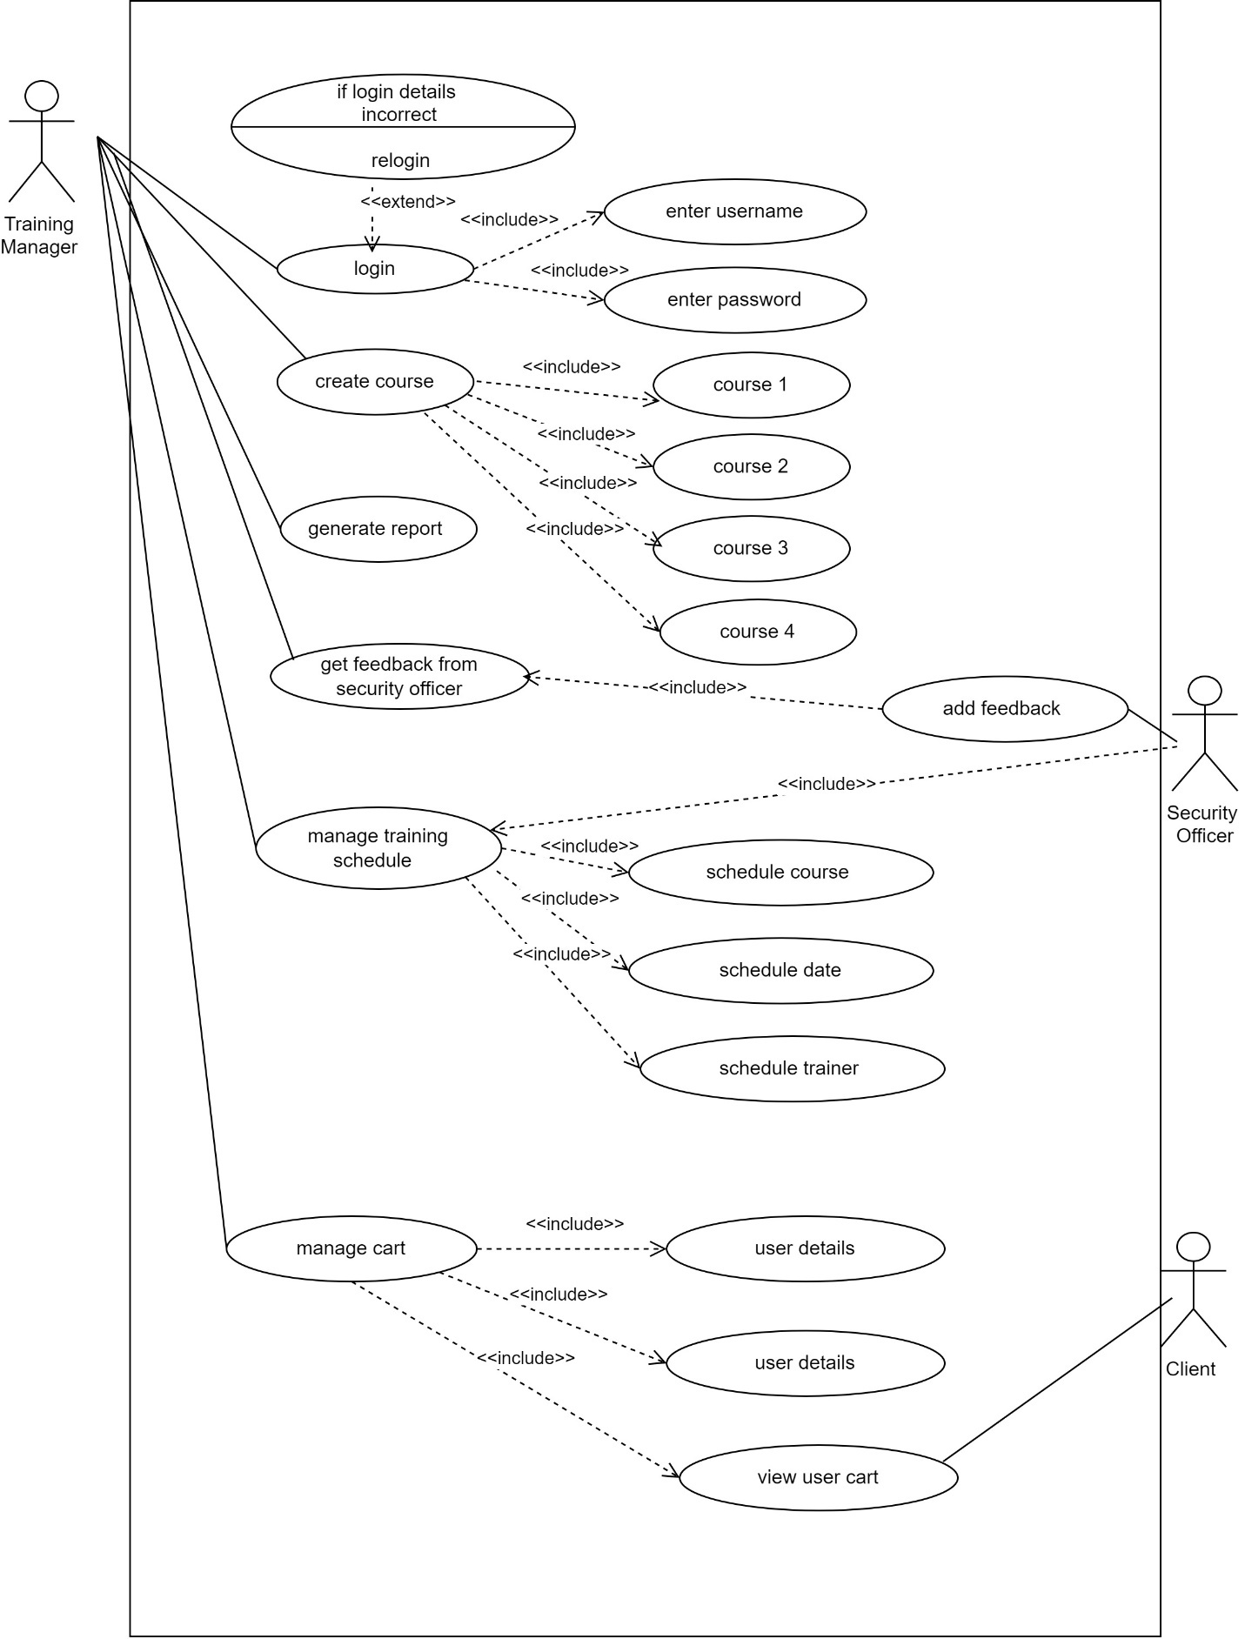

1. **Client Management: IT20145552 – Dissanayaka D. M. S. M**

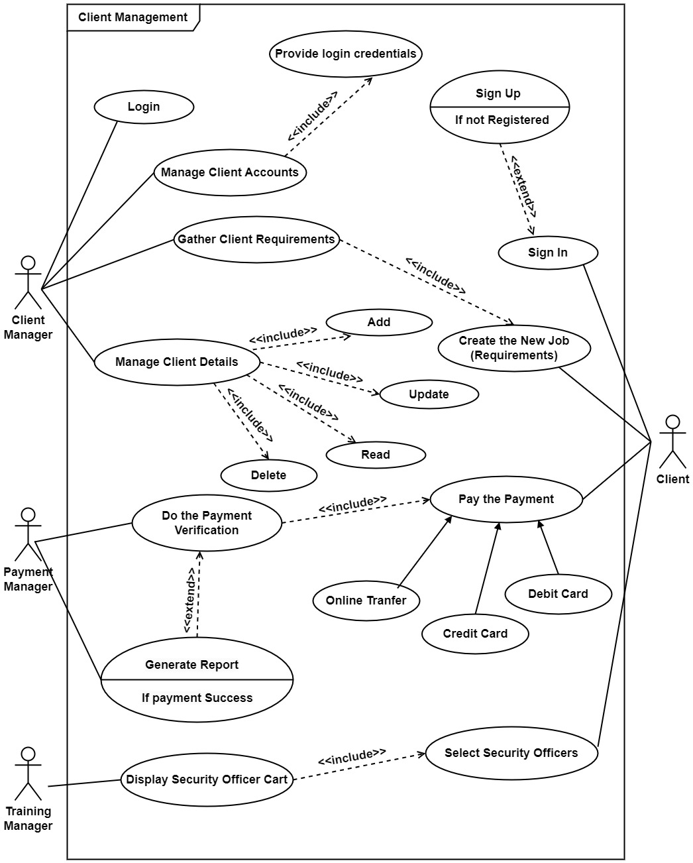

1. **Operation Management: IT22127082 - Medawatte W. W. M. T. N. B**

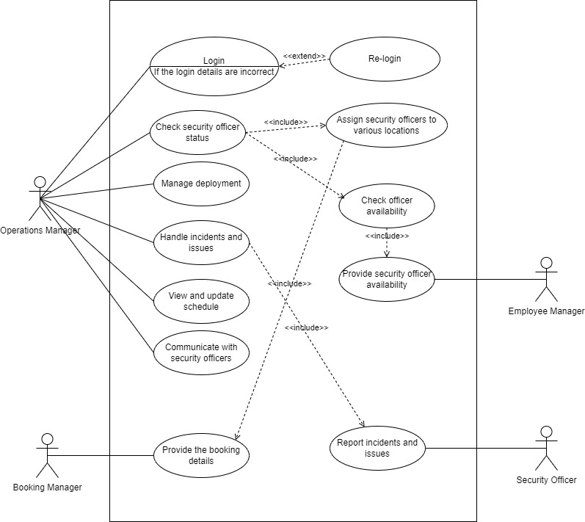

1. **Payment Management: IT22293480 - Jayodhya J. D. H**

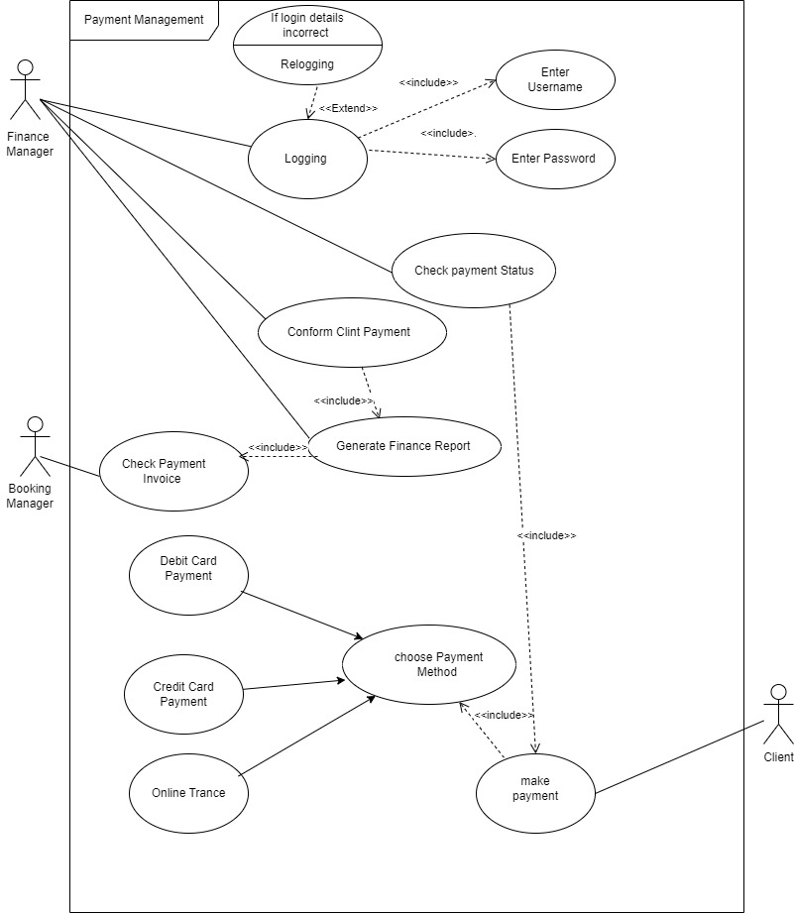

1. **Booking Management: IT22257086 -Randiw E. Y**

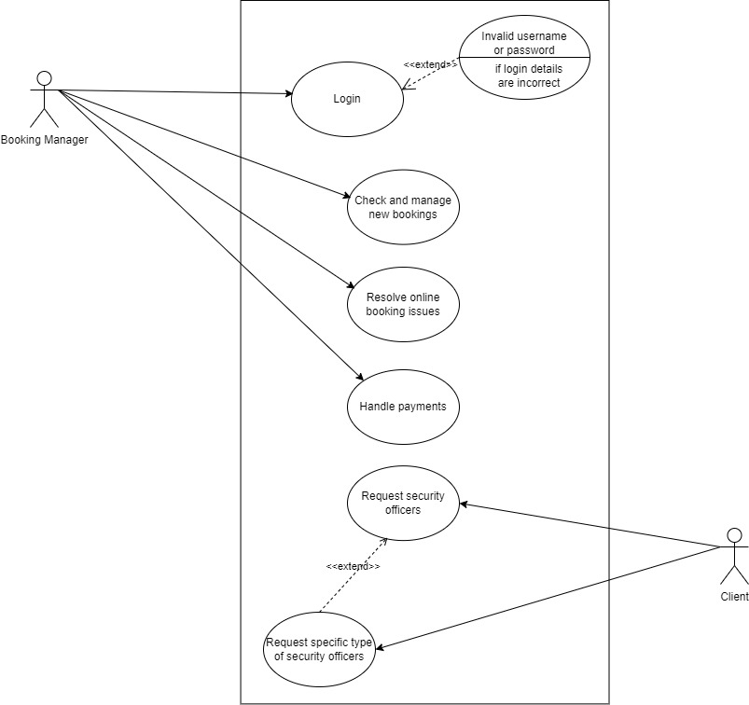

1. **Stock/Inventory Management: IT22132628 – Kusumsiri P. A. S. S**

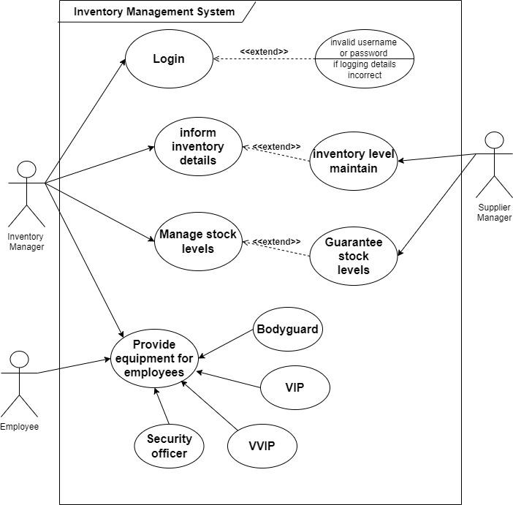

1. **Supplier Management: IT22197146 – Ranasinghe R. A. R. V. C**

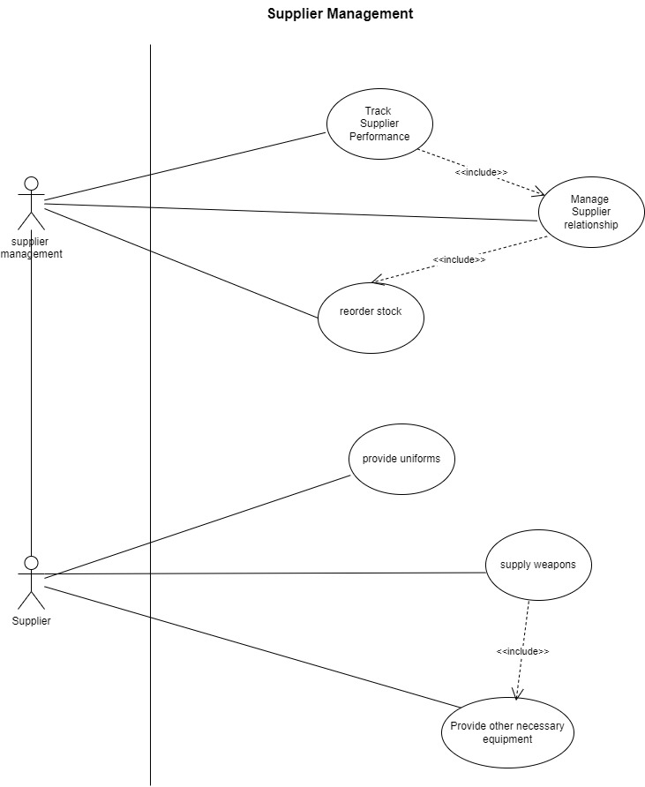

# PART 5

## 01. Use Case Scenario

1. **Employee Management: IT22325228 – Fernando K. K. C**

|  |  |  |
| --- | --- | --- |
| **Number** | 04 | |
| **Name** | Employee Recruitment Process | |
| **Summary** | Process of recruiting new employees, specifically security officers, into the organization. It includes steps such as job posting, application submission, candidate screening, interviews, and final selection. | |
| **Priority** | High | |
| **Pre-condition** | * The Manager has access to the employee management system. * Job requirements and qualifications have been defined and approved. * The system is ready to post job openings and manage applications. | |
| **Post-condition** | * The selected candidates are documented in the system. * Offers are extended to successful candidates. * The recruitment process for the specific role is completed. | |
| **Primary actor** | Manager / Employee Manager | |
| **Secondary Actor** | Job Candidate | |
| **Trigger** | A need for new security officers or other staff arises, prompting the recruitment process. | |
| **Main scenario** | **Step** | **Action** |
|  | 1. | The Manager creates a job posting for the required position, detailing the job title, qualifications, responsibilities, and application procedure. |
|  | 2. | Job Candidates submit their applications, including resumes and cover letters, through the system. |
|  | 3. | The Manager screens the applications to shortlist candidates based on predefined criteria such as qualifications, experience, and skills. |
|  | 4. | The Manager schedules interviews with shortlisted candidates, informing them of the date, time, and format of the interview. |
|  | 5. | The Manager (and possibly other panel members) conducts interviews with the shortlisted candidates, assessing their suitability for the role. |
|  | 6. | After completing the interviews, the Manager selects the most suitable candidates and discusses the decision with relevant stakeholders. |
|  | 7. | The Manager sends offer letters to the selected candidates, outlining the terms and conditions of employment. |
|  | 8. | The Manager closes the recruitment process for the role, updating the system with the final status of each candidate. |
| **Extensions** | **Step** | **Branching Action** |
|  | 3a | If no candidates meet the minimum criteria, the Manager decides to re-post the job or adjust the requirements. |
|  | 3b | The Manager revises the job posting and the recruitment process restarts. |
|  | 7a | If a selected candidate declines the offer, the Manager decides whether to extend the offer to another candidate or reopen the recruitment. |

1. **Training Management: IT22907998 - Sadisha R. M. M**

|  |  |  |
| --- | --- | --- |
| Number | 03 | |
| Name | Training Course Management | |
| Summary | A Training Manager logs into the system, creates training courses, schedules them, generates reports, manages the training cart, and collects feedback from the security officer. | |
| Precondition | * The Training Manager must have a valid login ID and Password. * The system must be accessible and operational. * Necessary permissions must be granted to the Training Manager for creating courses, managing schedules, generating reports, managing the cart, and accessing feedback from the security officer. | |
| Postcondition | * New training courses are created and visible in the system. * Training schedules are updated and available for trainees. * Reports are generated and stored for review. * The training cart is managed and updated. * Feedback from the security officer is recorded and accessible. | |
| Primary Actor | * Training Manager * Security Officer * Trainees (Indirectly involved) | |
| Trigger | The need to update or create new training courses and schedules, generate reports, manage the training cart, and review feedback from the security officer. | |
| Main Scenario | Step | Action |
| 1 | The Training Manager logs into the system using valid credentials. |
| 2 | * Navigates to the course creation module. * Enters details for each of the four courses (title, description, duration, etc.). * Saves the courses to the system. |
| 3 | * Accesses the scheduling module. * Assigns dates, times, and trainers to the newly created courses. * Ensures there are no conflicts with existing schedules * Saves the updated schedule. |
| 4 | * Navigates to the report generation module. * Selects the desired criteria (course completion, attendance, performance, etc.). * Generates and reviews the report. * Saves or prints the report for records. |
| 5 | * Accesses the training cart module. * Adds or removes courses from the cart as necessary. * Ensures the cart is up-to-date with the latest training offerings. * Saves changes to the cart. |
| 6 | * Reviews feedback submitted by the security officer regarding the training programs. * Makes any necessary adjustments to the courses or schedules based on the feedback. * Records the feedback in the system. |
| Extensions | Step | Action |
| 1.1 | * If the login fails due to incorrect credentials, the system prompts the Training Manager to re-enter the credentials. * After multiple failed attempts, the account may be temporarily locked, and the Training Manager will need to follow the account recovery procedure. |
| 2.1 | If there are issues with course creation (e.g., missing information or system errors), the system highlights the problem areas and prompts the Training Manager to correct them. |
| 3.1 | If there is a scheduling conflict, the system notifies the Training Manager and suggests alternative slots. |
| 4.1 | If report generation fails due to system errors, the Training Manager is notified and can retry the process. |
| 5.1 | If there are problems with managing the cart (e.g., system errors or unavailable courses), the system alerts the Training Manager to resolve the issues. |
| 6.1 | If the feedback from the security officer is unclear or incomplete, the Training Manager may need to seek clarification before making changes. |

1. **Client Management: IT20145552 – Dissanayaka D. M. S. M**

|  |  |  |
| --- | --- | --- |
| **Number** | 03 | |
| **Name** | Gather Client Requirements | |
| **Summary** | This use case describes the process by which the Client Manager gathers specific service requirements from a client for an upcoming event. This includes understanding the client's needs, documenting the event details, and ensuring all necessary information is collected for service provision. | |
| **Priority** | High | |
| **Pre-condition** | * The Client is logged into the system with an active account. * The Client Manager has access to the client management system and the client's account details. | |
| **Post-condition** | * The client's requirements are accurately documented in the system. * The system is updated with the event details, and the next steps for service provision are initiated. | |
| **Primary actor** | Client Manager | |
| **Secondary Actor** | Client | |
| **Trigger** | The Client contacts the Client Manager to request security services for an upcoming event. | |
| **Main scenario** | **Step** | **Action** |
|  | 1. | The Client logs into the system and initiates a request for security services by contacting the Client Manager. |
|  | 2. | The Client Manager contacts the Client to discuss the service requirements for the upcoming event. |
|  | 3. | The Client provides specific details about the event, including the date, time, location, type of event, and any special considerations (e.g., VIP protection, number of guests). |
|  | 4. | The Client specifies the number of security officers required, any preferred qualifications or special training (e.g., first aid, crowd control), and any specific gender preferences |
|  | 5. | The Client Manager and Client discuss any additional services needed, such as equipment rental, and logistic details like entry and exit protocols. |
|  | 6. | The Client Manager reviews the collected information with the Client for accuracy and completeness. Both parties confirm the documented requirements. |
|  | 7. | The Client Manager generates a preliminary service agreement based on the gathered requirements and sends it to the Client for review. |
| **Extensions** | **Step** | **Branching Action** |
|  | 3a | If the Client provides incomplete information, the system prompts the Client Manager to request additional details. |
|  | 3b | The Client Manager contacts the Client to gather the missing information. |
|  | 4a | If the Client decides to change the requirements after providing initial details, the Client Manager updates the records accordingly. |
|  | 4b | The Client Manager revisits the requirements with the Client. |

1. **Operation Management: IT22127082 - Medawatte W. W. M. T. N. B**

|  |  |  |
| --- | --- | --- |
| **Number** | 03 | |
| **Name** | Manage Operations | |
| **Summary** | The Operations Manager manages security deployments and communication tasks. | |
| **Priority** | High | |
| **Preconditions** | The operations manager is logged into the system and has access to operation management features. | |
| **Postconditions** | All scheduled operations are updated, incidents are addressed, and security officers are informed of their duties. | |
| **Primary Actor** | Operation manager | |
| **Trigger** | A scheduled shift changes or incident report is detected by the system | |
| **Main Scenario** | **Step** | **Action** |
| 1 | Operations Manager logs into the system using credentials. |
| 2 | System verifies login details. |
| 3 | Manager checks and views security officers' statuses. |
| 4 | Manager updates and saves the current schedule. |
| 5 | Manager communicates schedule changes or updates to officers. |
| 6 | System logs all communications between manager and officers. |
| 7 | Manager reviews and responds to reported incidents. |
| 8 | Manager assigns officers based on availability and needs. |
| 9 | System records assignments and updates officer statuses. |
| 10 | Manager coordinates with Booking Manager for event details. |
| 11 | System stores booking details from Booking Manager. |
| 12 | Manager monitors operations and addresses new issues or incidents. |
| **Extensions** | **Step** | **Action** |
| 2a | The system prompts the Operations Manager to re-enter the credentials. After three failed attempts, access is temporarily locked. |
| 5a | The system retries sending the message and logs the failure. An alert is sent to the Operations Manager to manually contact the officer. |
| 7a | The system escalates the issue to senior management and logs all actions taken in response. |
| 8a | The Operations Manager reschedules or reallocates existing officers based on priority needs. The system suggests possible options. |
| **Open issues** | 1 | Unresolved security incident at the main entrance. |

1. **Payment Management: IT22293480 - Jayodhya J. D. H**

|  |  |  |
| --- | --- | --- |
| Number | 03 | |
| Name | Finance Management | |
| Summary | The financial manager logs into the system, checks the payment method, confirms the client's payment, and generates a finance report. | |
| Precondition | * The financial manager must have valid login credentials. * The client must have initiated a payment. * The system must be operational and accessible. | |
| Postcondition | * The client's payment is confirmed and recorded in the system. * A finance report is generated and available for review or distribution. | |
| Primary Actor | * Financial Manager * Client * Payment System | |
| Trigger | A client makes a payment, prompting the financial manager to confirm and record the Payment. | |
| Main Scenario | Step | Action |
| 1 | The financial manager logs into the system using valid credentials. |
| 2 | The system verifies the login credentials and grants access. |
| 3 | The financial manager navigates to the payment section. |
| 4 | The financial manager checks the client's payment method. |
| 5 | The system retrieves and displays the client's payment information. |
| 6 | The financial manager confirms the client's payment. |
| 7 | The system records the payment confirmation. |
| 8 | The financial manager confirms the client’s payment. |
| 9 | The system complies and generates the finance report |
| 10 | The financial manager reviews and saves the finance report. |
| Extensions | Step | Action |
| 1.1 | The financial manager enters incorrect credentials. |
| 1.2 | The system displays an error message and prompts for re-entry. |
| 4.1 | The financial manager checks the payment method, but the system does not find it. |
| 4.2 | The system displays an error message. |
| 4.3 | The financial manager contacts the client for clarification. |
| 8.1 | The system encounters an error while generating the finance report. |
| 8.2 | The system logs the error and notifies the financial manager. |
| 8.3 | The financial manager retries generating the report. |

1. **Booking Management: IT22257086 -Randiw E. Y**

|  |  |  |
| --- | --- | --- |
| Name | Manage Bookings | |
| Summary | A Booking Manager checks for new bookings, updates their statuses, and allocates necessary resources to handle client requests efficiently | |
| Priority | 1 | |
| Pre-conditions | • The Booking Manager is logged into the system.  • There are new bookings in the system awaiting review | |
| Post-conditions | • Bookings are updated with the appropriate status.  • Security officers are allocated to the events.  • Notifications are sent to clients regarding the status of their bookings | |
| Primary Actors(s) | Booking Manager | |
| Secondary Actor(s) | Client | |
| Main Scenario | **Step** | **Action** |
| 1 | The Booking Manager logs into the system using their credentials. |
| 2 | The Booking Manager navigates to the bookings section in the system dashboard. |
| 3 | The system displays a list of new bookings that need attention. |
| 4 | The Booking Manager updates the status of each booking (e.g., approved, pending, rejected) based on the review. |
| 5 | The system records the updates and allocations made by the Booking Manager. |
| 6 | The system automatically sends notifications to clients about the status of their bookings and any assigned security officers. |
| Extensions | **Step** | **Branching action** |
| 5a | The Booking Manager updates the booking once the required information is received. |
| 6a | The Booking Manager informs the client of any changes to the original booking. |

1. **Stock/Inventory Management: IT22132628 – Kusumsiri P. A. S. S**

|  |  |  |
| --- | --- | --- |
| Number | 02 | |
| Name | Informing Inventory Details and Maintaining Inventory Levels | |
| Summary | Coordinate between the Inventory Manager and Supplier Manager to maintain optimal inventory levels by reviewing stock, compiling details, placing orders, and updating records to ensure timely restocking. | |
| Precondition | * The Inventory Manager has access to the current inventory system. * The Supplier Manager has access to the inventory and supplier management systems. | |
| Postcondition | * The Supplier Manager is informed about the inventory details. * The Supplier Manager updates the stock levels as needed. | |
| Primary Actor | * Inventory Manager (IM) * Supplier Manager (SM) | |
| Trigger | The Inventory Manager identifies that stock levels of certain items are low or depleted during a routine inventory review or when alerted by the inventory management system's low-stock notifications. | |
| Main Scenario | Step | Action |
| 1 | The Inventory Manager logs into the system using valid credentials. |
| 2 | * The Inventory Manager periodically reviews the current inventory levels in the system. * The system shows that certain items are running low or are out of stock. |
| 3 | * The Inventory Manager compiles a detailed report of current stock levels, including the quantities of items that need restocking. * The report also includes any special instructions or priority needs. |
| 4 | * The Inventory Manager sends the inventory details report to the Supplier Manager via email or a designated communication platform. * The report includes information such as item names, quantities needed, and preferred delivery times. |
| 5 | * The Supplier Manager receives the report and reviews the inventory details. * The Supplier Manager checks current supplier stock and assesses the feasibility of restocking the items. |
| 6 | * Based on the inventory details provided, the Supplier Manager places orders with the suppliers to restock the items. * The Supplier Manager updates the inventory system with the new stock levels and expected delivery dates. |
| 7 | * The Inventory Manager monitors the updated inventory system to ensure that stock levels are replenished as per the orders placed. * The Inventory Manager also reviews any notifications or updates from the Supplier Manager regarding the status of the restocking process. |
| 8 | Once the stock is received, the Supplier Manager confirms the delivery and updates the inventory system with the received quantities. |
| 9 | * The Inventory Manager provides feedback on the restocking process and any discrepancies found. * Both the Inventory Manager and Supplier Manager discuss any adjustments needed for future orders. |
| Extensions | Step | Action |
| 2.1 | The Inventory Manager conducts a physical inventory check to resolve discrepancies. The updated data is communicated to the Supplier Manager for accurate restocking. |
| 3.1 | * Inventory Manager Informs Supplier Manager About Stock Details for Restocking * There is a delay in the transmission of inventory details between the Inventory Manager and Supplier Manager. |
| 4.1 | The Inventory Manager adjusts inventory plans to comply with regulations. The Supplier Manager works to ensure that all ordered items meet the new compliance requirements. |
| 5.1 | The Inventory Manager prioritizes critical items for restocking and adjusts orders accordingly. The Supplier Manager is informed of the revised order quantities and delivery schedules. |
| 7.1 | The Supplier Manager coordinates with the supplier to resolve the issue, arranges for replacements or corrections, and updates the Inventory Manager on the situation. |

1. **Supplier Management: IT22197146 – Ranasinghe R. A. R. V. C**

|  |  |  |
| --- | --- | --- |
| **Number** | 03 | |
| **Name** | Buying Uniforms | |
| **Summary** | The Supplier Manager purchases uniforms from the Supplier to ensure security officers have the proper attire for their duties. | |
| **Priority** | 2 | |
| **Pre-condition** | The Supplier Manager is logged into the Supplier Management System, and the system has access to supplier catalogs. | |
| **Post-condition** | Uniforms are ordered from the Supplier, and the order details are logged in the system. | |
| **Primary actor** | Supplier Manager | |
| **Trigger** | The stock of uniforms reaches a reorder level, or there is a new requirement for uniforms. | |
| **Main Scenario** | **Step** | **Action** |
|  | **1** | The Supplier Manager identifies the need for new uniforms. |
|  | **2** | The Supplier Manager logs into the Supplier Management System |
|  | **3** | The Supplier Manager navigates to the uniform supply section |
|  | **4** | The Supplier Manager reviews the available suppliers and their catalogs. |
|  | **5** | The Supplier Manager selects the required uniforms and places an order. |
|  | **6** | The system sends the order request to the Supplier. |
|  | **7** | The Supplier processes the order and confirms the order details. |
|  | **8** | The Supplier Manager receives the confirmation and order details are logged in the system. |
| **Extensions** | **Step** | **Branching Action** |
|  | **4a** | If no suitable supplier is found, the Supplier Manager can search for new suppliers. |
|  | **5a** | If the selected uniforms are out of stock, the Supplier Manager can choose an alternative or backorder the uniforms. |
|  | **7a** | If the Supplier cannot fulfill the order, the Supplier Manager will be notified and must select a different supplier. |